PARTNER PLAN

Ida & Keith Waddell – Zambia
Holy Week 2026

26 March 2026

The United Church of Zambia
Mwandi Mission
Box 60693
LIVINGSTONE
Zambia

E-mail:keithida2014@gmail.com
Cell phone: +260964761039 (Ida)
+260977143692

Dear Family and Friends

Look to the Lord and his strength; seek his face always. Remember the wonders he has done, his miracles, and the judgments he pronounced, Psalm 105:4-5

We chose this Psalm as it puts into words our experience and that of the community here on the Mission, remembering our own circumstances, our struggles and frailty yet throughout it all the mercies of God’s providence. We balance the offering of praise with the need for his active help in this hard world, as we plan and work together.

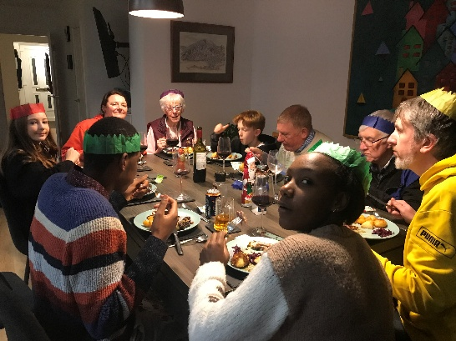
We enjoyed our Christmas celebrations with Kirsten Stuart and the family in Lenzie, then welcomed Catriona, Will and their two to Edinburgh. Ellie was also able to visit friends in Northampton and Hamilton during her time here. While Catriona and Will brought in the New Year at Lenzie, the four of us set off to North Wales to see Gregor Sarah, Maia and Elsi as well as Nain in Bangor.

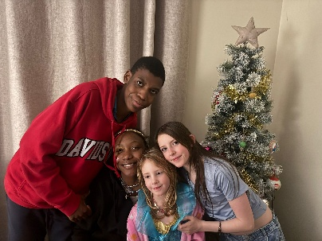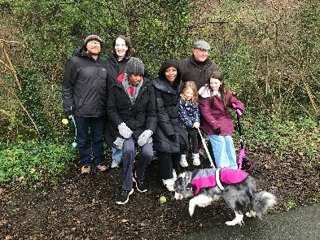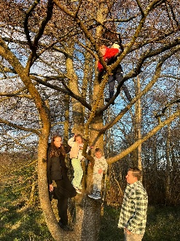
Before this we attended the cremation service in Kirkcaldy for Helen, our sister-in-law and Eric’s wife, who had passed away peacefully on 4 December after a long and gallant fight with Wolfram syndrome. It was good that we were back home at this time.
Before Christmas too we had a visit from Klaus and Eva from Germany. This was a surprise for Klaus’ 70th birthday. Klaus and I were pen-pals at school and stayed at each other’s homes, so it was good to catch up again.

On our return from Wales, Will and Ellie flew back to Zambia on 8th January while Catriona and Ida went to Vision Scotland for the first session of laser treatment for her
Bilateral Pinguecula. Amazingly, the Doctor, Naomi Scott, who did Catriona's
laser treatment called Ida in at Cats' request, because of the chronic nature of the diagnosis. They recognised each other as Naomi is a member at Callander Kirk and met us there when we were speaking on 30 November; she was with the Youth Choir!
The treatment required us to ask the Church of Scotland if it would be possible for Keith to extend his stay with Catriona and the two grandchildren for another 14 days from the 4th February to 18th February. This was agreed and Ida and Mubita flew back to Lusaka as planned on 6th. Ida had meetings in Chitambo and Lusaka to attend and purchases and supplies to organise, while Keith remained with Catriona and the wee ones. It was a good time, doing home-school, visiting the park, zoo and museums and getting to know them better. Catriona’s last session of treatment was on 10th February, but we had to wait one week after the treatment before we flew which we did on 19th February getting home in good time, just before all the trouble over Iran began.

Before Ida left, we spoke at Services at Abdie and Crieff. We enjoyed meeting auld acquaintances at Newburgh thanks to Valerie and meeting some new ones at Crieff. We spoke to the Church and Primary School at Bankfoot, before finishing off our deputation at Houston. Irene dropped us off at a Saturday Fundraising Breakfast organised by Caroline and her team and on the Sunday answering very interesting questions put to us by the Sunday School. We also enjoyed a game of 10-pin bowling and meal together and hospitality from Kate and Graeme.

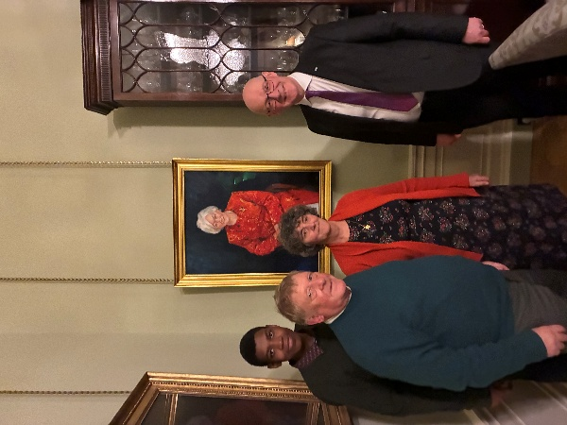
Following the visit of the First Minister to Zambia, we were invited to a reception at Bute House in early February, where we were able to talk further about our work at Mwandi and seek Scottish Government support in contributing to it in established areas. It was a great pleasure too to see the state apartments with their Georgian features, works of art and silverware.

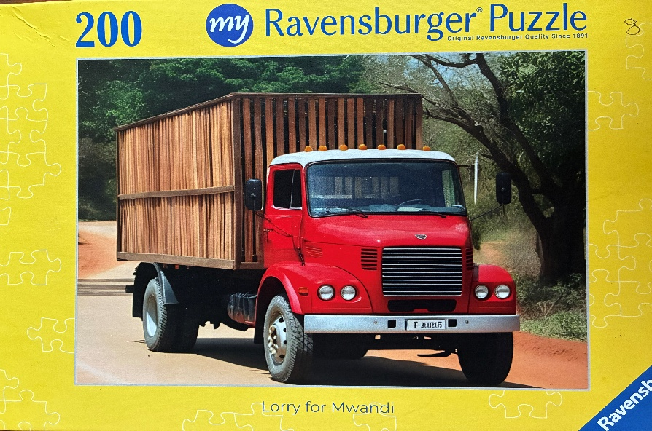
We have reached an amazing total with regard to the truck and are now actively seeking to purchase it. It will either be purchased locally which is easier logistically but choice is limited. Greater choice is availably regionally but importing from South Africa is problematic and time consuming. The best option is a reconditioned truck from Europe or Japan but that too has its bureaucratic hoops to jump through. We hope we can report a successful purchase in our next letter. Our grateful thanks to all of you who organised and contributed so generously to this need.

Since returning we have been busy with a visiting US Gynaecological surgeon, who undertook a number of reconstructive procedures. We also attended the Western Presbytery Council in Mongu with our reports as Education and Health Convenors . The meeting was called to form a Nominations Committee as our present Bishop Roy Kanchele will retire after his two terms. The Committee will short-list 3 candidates for election at the Synod Executive later in the year. We travelled on to Lusaka where Ida attended the CHAZ Board Meeting while Keith visited the Bible Society and purchase 64 Silozi Bibles and did some follow-up to the repossession process of a former Mission Schools in Western Province. On our return Ida has been doing follow-up work from CHAZ and organising the servicing of medical equipment, prior to the forthcoming visit of Peggy Schrieber’s Surgical team. The local Hospital Board and the International Board meetings are taking place shortly too. Keith is organising the logistics for build two double VIP pit latrines at Sikuzu.

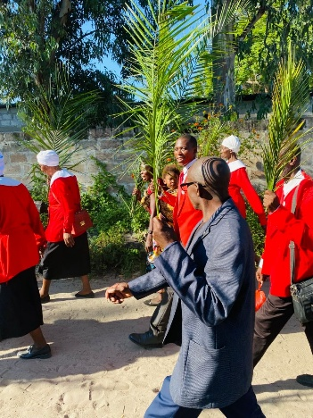
As we approach our celebration of the Resurrection, we rejoice in expectation of a better world, instead of the negativity and defeatism that seems to prevail. We know that here and now in the midst of all there is hope in the presence of our risen Lord. On Good Friday with his crucifixion, he demonstrated his patient, sacrificial love. A love which endures through all the failures and suffering we see and experience so we can proclaim Christ has died, Christ is risen Christ will come again.

With our love

Keith & Ida

